Hamza Salahuddin
24k-3065
Lab-07
Q1
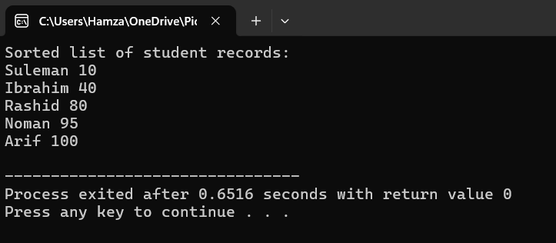
#include <iostream>
#include <string>
using namespace std;

#define SIZE 10

struct Node {
string name;
int score;
Node* next;
};

void addNode(Node** head,string name,int score) {
Node* newNode=new Node();
newNode->name=name;
newNode->score=score;
newNode->next=*head;
*head=newNode;
}

int getMax(Node* head) {
int maxVal=head->score;
Node* temp=head;
while (temp!=NULL) {
if (temp->score >maxVal)
maxVal=temp->score;
temp=temp->next;
}
return maxVal;
}

Node* countingSort(Node* head, int exp) {
Node* buckets[10] = {NULL};
Node* tails[10] = {NULL};

Node* temp = head;
while (temp != NULL) {
int index = (temp->score / exp) % 10;

Node* newNode = new Node();
newNode->name = temp->name;
newNode->score = temp->score;
newNode->next = NULL;

if (buckets[index] == NULL) {
buckets[index] = tails[index] = newNode;
} else {
tails[index]->next = newNode;
tails[index] = newNode;
}

temp = temp->next;
}

Node* sortedHead = NULL;
Node* sortedTail = NULL;
for (int i = 0; i < 10; i++) {
if (buckets[i] != NULL) {
if (sortedHead == NULL) {
sortedHead = buckets[i];
sortedTail = tails[i];
} else {
sortedTail->next = buckets[i];
sortedTail = tails[i];
}
}
}

return sortedHead;
}

void radixSort(Node** head) {
int maxVal = getMax(*head);
for (int exp=1;maxVal / exp >0; exp *= 10)
*head = countingSort(*head, exp);
}

void display(Node* head) {
Node* temp = head;
cout << "Sorted list of student records:" << endl;
while (temp != NULL) {
cout << temp->name << " " << temp->score << endl;
temp = temp->next;
}
}
int main() {
Node* head = NULL;

addNode(&head, "Noman", 95);
addNode(&head, "Suleman", 10);
addNode(&head, "Ibrahim", 40);
addNode(&head, "Rashid", 80);
addNode(&head, "Arif", 100);

radixSort(&head);
display(head);

return 0;
}

Q4
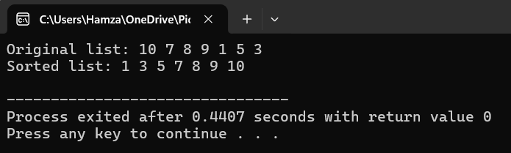
#include<iostream>
using namespace std;
class Node{
public:
int data;
Node* next;
Node(int value){
data=value;
next=NULL;
}
};

class SinglyLinkedList{
public:
Node* head;
Node* tail;
SinglyLinkedList(){
head=NULL;
tail=NULL;
}
void insert(int val) {
Node* newNode = new Node(val);
if (!head) {
head = tail = newNode;
} else {
tail->next = newNode;
tail = newNode;
}
}
void swap(Node* h1, Node* h2) {
int temp = h1->data;
h1->data = h2->data;
h2->data = temp;
}

void QuickSort(Node* head,Node* tail){
if(!head||!tail||head==tail){
return ;
}
Node* pivot=partition(head,tail);
Node* temp=head;
Node* pre=NULL;
while(temp!=pivot){
pre=temp;
temp=temp->next;
}
if(pre){QuickSort(head,pre);}
if(pivot!=NULL && pivot->next!=NULL){QuickSort(pivot->next,tail);}
}

Node* partition(Node* head,Node* tail){
int pivot=tail->data;
Node* i=head;
Node* j=head;
while(j!=tail){
if(j->data<pivot){
swap(i,j);
i=i->next;
}
j=j->next;
}
swap(i,tail);
return i;
}

void print() {
Node* temp = head;
while (temp) {
cout << temp->data << " ";
temp = temp->next;
}
cout << endl;
}

};
int main() {
SinglyLinkedList list;
list.insert(10);
list.insert(7);
list.insert(8);
list.insert(9);
list.insert(1);
list.insert(5);
list.insert(3);
cout << "Original list: ";
list.print();

list.QuickSort(list.head, list.tail);

cout << "Sorted list: ";
list.print();
}
Q5(a)
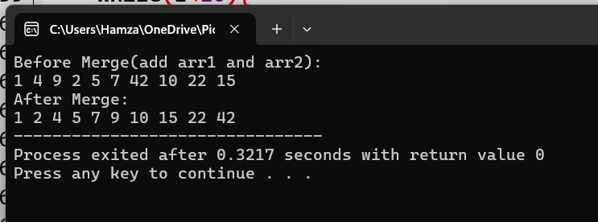
#include<iostream>
using namespace std;

void Merge(int arr[],int low ,int mid ,int high){
int i=low;
int j=mid+1;
int k=0;
int temp[high-low+1];
while(i<=mid && j<=high){
if(arr[i]<arr[j]){
temp[k]=arr[i];
i++;
k++;
}
else{
temp[k]=arr[j];
j++;
k++;
}

}
while(i<=mid){
temp[k]=arr[i];
i++;
k++;
}
while(j<=high){
temp[k]=arr[j];
j++;
k++;
}
int m=0;
for(int t=low;t<=high;t++){
arr[t]=temp[m];
m++;
}
}
void MergeSort(int arr[],int low,int high){
if(low<high){
int mid=low+(high-low)/2;
MergeSort(arr,low,mid);
MergeSort(arr,mid+1,high);
Merge(arr,low ,mid,high);
}
}
int main(){
int arr1[]={1,4,9,2,5};
int arr2[]={7,42,10,22,15};
int arr3[10];
int w=sizeof(arr1)/sizeof(arr1[0]);

int i=0;
while(i<w){
arr3[i]=arr1[i];
i++;
}

int k=0;
while(i<10){
arr3[i]=arr2[k];
i++;
k++;
}
cout<<"Before Merge(add arr1 and arr2):"<<endl;
for(int i=0;i<10;i++){
cout<<arr3[i]<<" ";
}
cout<<endl;
int n=sizeof(arr3)/sizeof(arr3[0]);
cout<<"After Merge:"<<endl;
MergeSort(arr3,0,n-1);
for(int i=0;i<n;i++){
cout<<arr3[i] <<" ";
}
}
Q5(B)

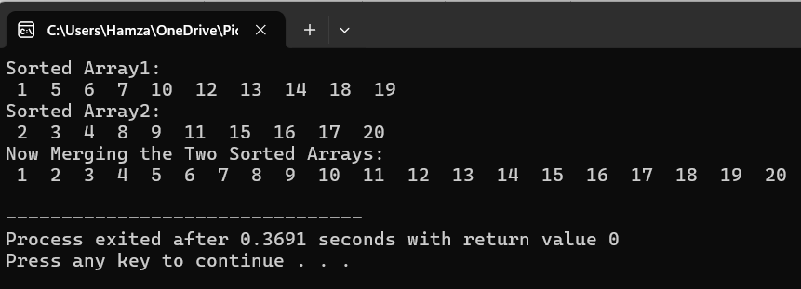
#include <iostream>
using namespace std;

void CountingSort(int arr[], int n, int exp) {
int output[n];
int count[10] = {0};

for (int i = 0; i < n; i++)
count[(arr[i] / exp) % 10]++;

for (int i = 1; i < 10; i++)
count[i] += count[i - 1];

for (int i = n - 1; i >= 0; i--) {
int index = (arr[i] / exp) % 10;
output[count[index] - 1] = arr[i];
count[index]--;
}

for (int i = 0; i < n; i++)
arr[i] = output[i];
}

void RadixSort(int arr[], int n) {
int maxVal = arr[0];
for (int i = 1; i < n; i++)
if (arr[i] > maxVal)
maxVal = arr[i];

for (int exp = 1; maxVal / exp > 0; exp *= 10)
CountingSort(arr, n, exp);
}

void MergeArray(int array1[], int array2[], int n, int merged[]) {
int i = 0, j = 0, k = 0;

while (i < n && j < n) {
if (array1[i] <= array2[j]) {
merged[k++] = array1[i++];
} else {
merged[k++] = array2[j++];
}
}

while (i < n)
merged[k++] = array1[i++];

while (j < n)
merged[k++] = array2[j++];
}

void PrintArray(int array[], int n) {
for (int i = 0; i < n; i++)
cout << " " << array[i] << " ";
cout << endl;
}

int main() {
int n = 10;

int array1[n] = {12, 19, 14, 1, 18, 6, 7, 13, 5, 10};
int array2[n] = {9, 2, 4, 17, 8, 11, 3, 20, 15, 16};

RadixSort(array1, n);
RadixSort(array2, n);

cout << "Sorted Array1: " << endl;
PrintArray(array1, n);

cout << "Sorted Array2: "<<endl;
PrintArray(array2, n);

cout << "Now Merging the Two Sorted Arrays:" <<endl;
int merged[2*n];
MergeArray(array1, array2,n,merged);

PrintArray(merged,2*n);

return 0;
}
Quick Sort with different pivots
1)Select First element
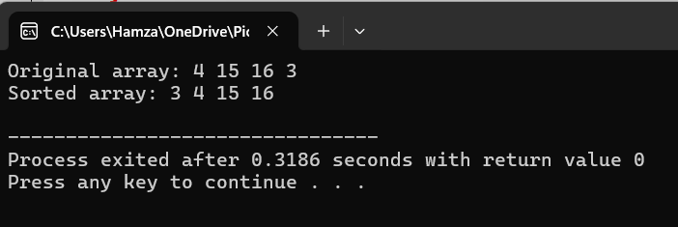
#include<iostream>
using namespace std;

int partition(int arr[],int low,int high){
int pivot=arr[low];
int i=low;
int j=high;
while(i<j){
while(arr[i]<=pivot && i<=high){
i++;
}
while(arr[j]>pivot && j>=low){
j--;
}

if(i<j){
swap(arr[i],arr[j]);
}
}
swap(arr[j],arr[low]);
return j;
}
void QuickSort(int arr[],int low, int high){
if(low<high){
int pivot=partition(arr,low,high);

QuickSort(arr,low,pivot-1);
QuickSort(arr,pivot+1,high);
}
}
int main(){
int arr[]={4,15,16,3};
int n=sizeof(arr)/sizeof(arr[0]);
cout << "Original array: ";
for (int i = 0; i < n; i++)
cout << arr[i] << " ";
cout << endl;
QuickSort(arr,0,n-1);
cout << "Sorted array: ";
for (int i = 0; i < n; i++)
cout << arr[i] << " ";
cout << endl;
return 0;
}

